COVER LETTER

Department of Biotechnology
School of Science, Federal university of technology
P.M.B. 1526, Owerri
Imo state, Nigeria

The Editor
AJMS

Dear Editor,

COVER LETTER OF DECLARATION

We, the authors of the above paper for publication titled ‘PREVALENCE AND ANTIBIOGRAM OF MULTI-DRUG RESISTANT STAPHYLOCOCCUS AUREUS AMONG PREGNANT WOMEN ATTENDING ANTE-NATAL CLINICS IN OWERRI, IMO STATE, NIGERIA’ hereby declare that this is a write up of an original research carried out by us and that it is not being considered for publication in any other Journal.
Upon acceptance by Asian Journal of Medical Sciences, all copyright ownership for the article is transferred to Asian Journal of Medical Sciences. We, the undersigned co-authors of this article, have contributed significantly to and share in the responsibility for above. The undersigned stipulate that the material submitted to Asian Journal of Medical Sciences is new, original and has not been submitted to another publication for concurrent consideration.
We attest that this study which include human subjects from which this manuscript was derived are in compliance with regulation of our institution(s) and with generally accepted guidelines governing such work see appendix 1, ethical committee permission below.
We also declare that this work was funded by us the researchers and no external fund was received. We therefore attest that we have herein disclosed any and all financial or other relationships which could be construed as a conflict of interest and that all sources of financial support for this study have been disclosed.
This manuscript has been seen and approved by all authors involved. The corresponding author is authorized to stand in and sign on behalf of all the authors.

Thanks.
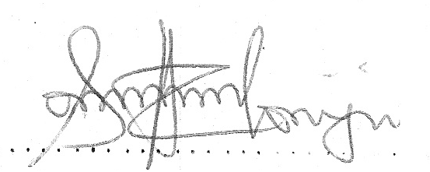
Anyadoh Sylvia. O
Corresponding author
On behalf of the Researchers

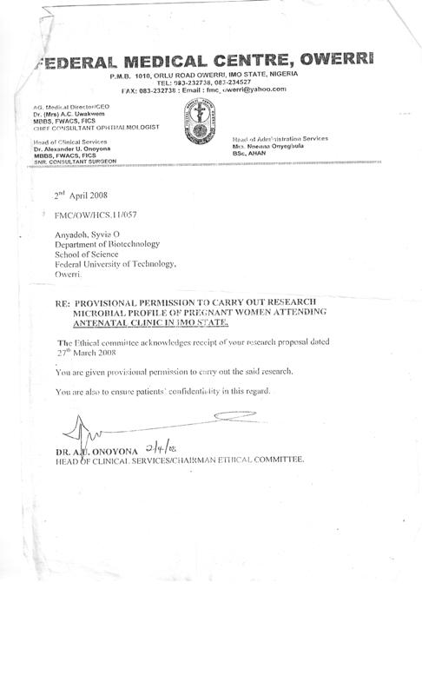
APPENDIX 1: ETHICAL PERMISSION LETTER

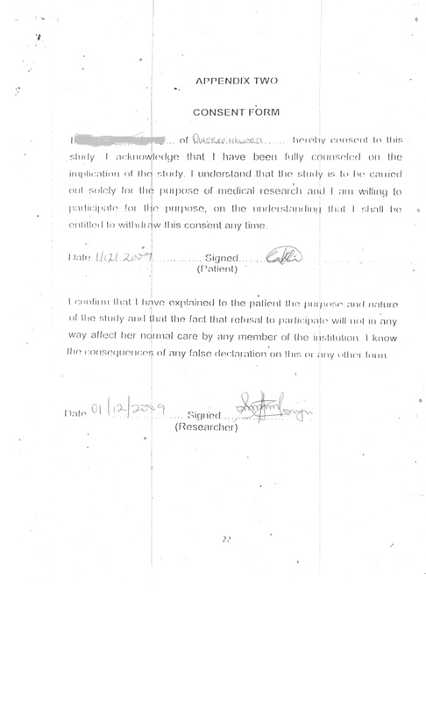
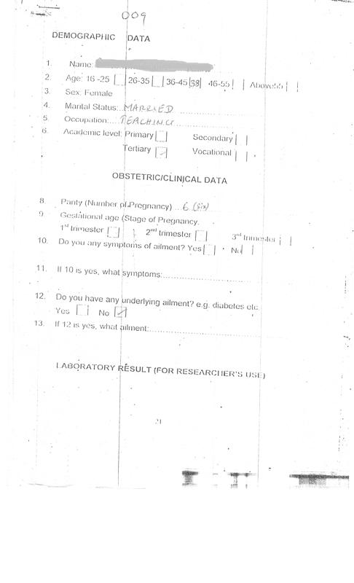
APPENDIX THREE: SAMPLE OF COMPLETED QUESTIONAIRE

