Supplement:
Figure 1: Geographical map of the study area (Samanta et al.)
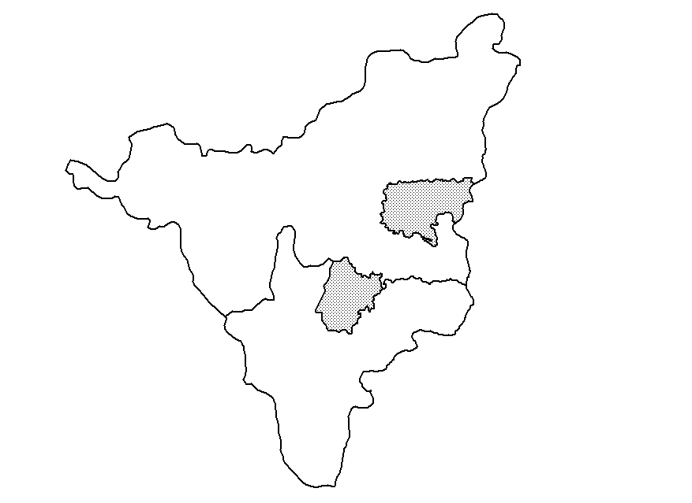
HOOGHLY district
SINGUR block
HOWRAH
district
JAGATBALLAVPUR block
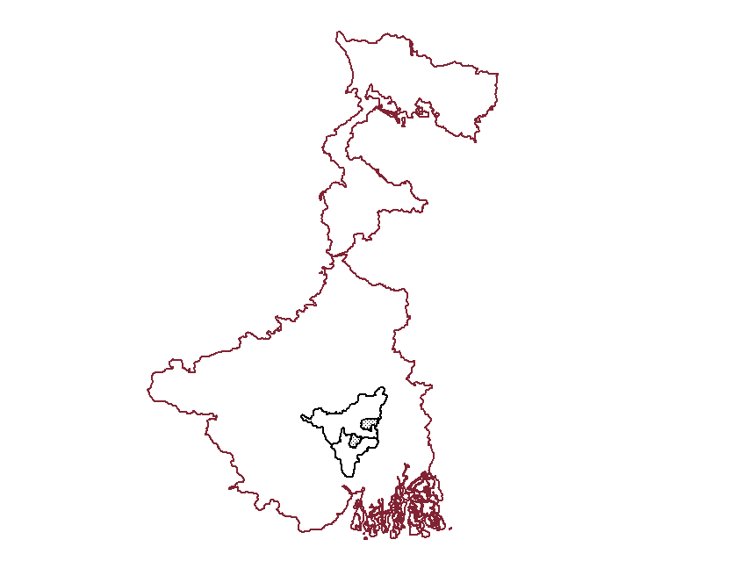
WEST BENGAL

